IFT 266 Introduction to Network Information Communication Technology (ICT)
Lab 9
Switch Configuration – Telnet Connection

After you complete each step, put an ‘x’ in the completed box

Connect to the switch using a telnet connection.
Let’s take a step back for second and consider the following…

- When the router or manageable switch is first put into service, no network parameters are configured so the router or switch cannot communicate with the network (router) or no have all its functionality enabled (switch).
- Networking devices usually do not have their own displays, keyboards or other input devices.
- Accessing a network device for monitoring, configuration, verification, troubleshooting is made via a connection between the device (switch or router) and a computer.
- To prepare for initial setup and configuration, we will connect a computer to the switch or router.
- The computer will run a terminal emulation program to provide a text based session/connection with the switch or router. Via this session, the network administrator can manage the switch or router.
- Some examples of terminal emulators re Putty.exe (freely available www.putty.org), TeraTerm, ProComm Plus, Z-Terminal on Apple MAC, Mini Com on Linux, HyperTerminal (older versions of Windows operating system i.e. XP and previous).
- Once you confirm the Com Port settings (terminal emulator configuration complete), the program will attempt to connect to the router

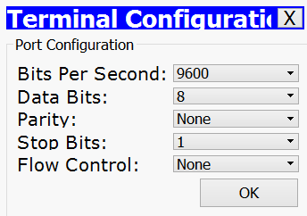
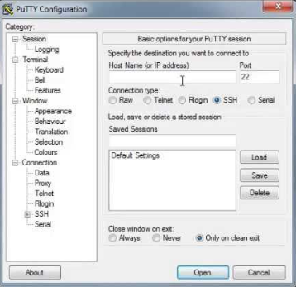
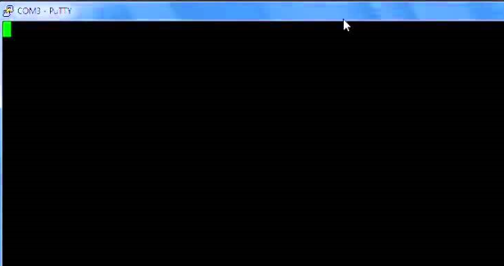
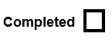

- Now will setup a telnet line on the switch so you can access the switch remotely. Switches and routers can be managed over the network by using standard TCP/IP protocols like Telnet and SSH (more secure version than Telnet).
Telnet app allows a terminal (computer) to remotely communicate with a device i.e. switch or router.

Telnet with IP network sends and receives the data remotely, rather than a specialized cable and physical port on the device. This was the case in Part A of this lab where we directly connected computer with the switch via a console cable to the console port on the switch.

To be able of using Telnet, the user must install Telnet client software onto computer i.e. terminal emulation software. The switch or router runs Telnet server software by default, but the switch or router does need to have an IP address configured so that it can send and receive IP packets

With Telnet you have potentially 5 (0 -4) or 16 (0 -15) separate lines, so 5 or 16 people can log onto the switch at the same time.

- Setup the following topology as show (straight through cable will work).

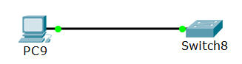

- As we mentioned in Step 8, to access the switch remotely we need to have an IP address setup on switch. You might wonder how to setup an IP on a switch since you can’t assign an IP to one of the ports like a router.
To do this you will need to give an IP address to a VLAN on the switch (we will discuss VLAN is more detail in Lab 9).

Before we assign the IP address to the VLAN, we need to setup the Terminal Sever on the switch by entering the following commands (we will also setup a console connection)

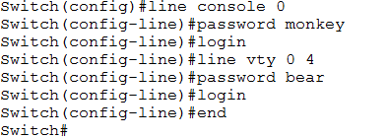

Let’s look at what these commands mean
- The “line vty” command enable the telnet and the “0 4″ sets up to 4 possible concurrent session to the switch. If you need more sessions simultaneously, you could type “line vty 0 15“ depending on the model of the switch and how many connection you need.
- The “password” command set “bear” as password for Telnet. You can set your own password.
- The “login” command authenticate and ask you the password of telnet. If you type “no login” command, the telnet never authenticate

- We will now give VLAN 99 an IP address as we outlined in Step 10. You do not have to use VLAN 99.
After we specify the interface, apply the IP address with a subnet mask, we use the ‘no shutdown’ command to turn on the interface.
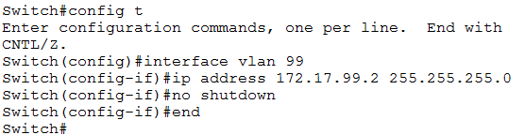

- We now need to specify that that the Ethernet port fa0/1 on the switch is an access port and this port is for a switch to host connection and this port is assigned to only one VLAN in our case 99 (this will be covered in more detail in Lab 8 (Setting up VLANs). Notice that VLAN99 is now up.

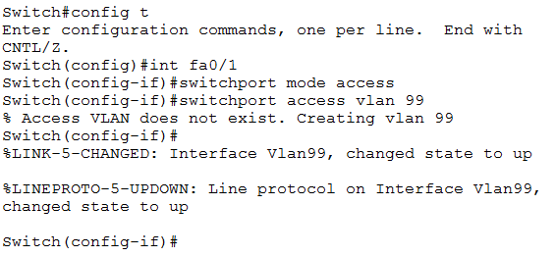

- Now we need to setup an IP address on the PC. Go into the PC, desktop tab, IP configuration and add in the IP address to the PC with the subnet mask. The IP address should be in the same range as VLAN1.

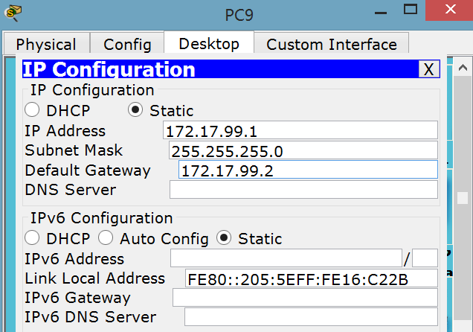

- On the PC you should now be able to Telnet into the switch from the command line.
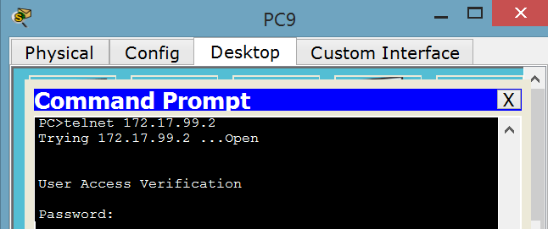

Attach a screenshot of your successful Telnet connection!

